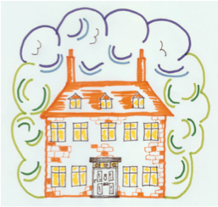
Hopton School House Charity No.1053436
18 Hopton Road PATA No. D019P
Cam OFSTED No. EY239574
Glos GL11 5PB

Tel. 01453 542489
www.hoptonschoolhouse.com
email:mailhoptonschoolhouse@yahoo.co.uk

HOPTON SCHOOL HOUSE OUT OF SCHOOL CLUB BOOKING FORM

Please fill in name(s) of the child(ren) requiring places:

Full Name (1)
Full Name (2)
Full Name (3)

Breakfast Club Session 7.30am – 8.45am OOSC Session 3.00pm – 6.00pm

Please enter the dates of the bookings required below and enter the total fees payable. Fees are payable on booking: Bank Details: Barclays, sort code 20-84-58 account number 43317854

Day | Session | Places required |  | Cost
Monday | Breakfast Club |  | £ 5.00
 | OOSC |  | £12.25
Tuesday | Breakfast Club |  | £ 5.00
 | OOSC |  | £12.25
Wednesday | Breakfast Club |  | £ 5.00
 | OOSC |  | £12.25
Thursday | Breakfast Club |  | £ 5.00
 | OOSC |  | £12.25
Friday | Breakfast Club |  | £ 5.00
 | OOSC |  | £12.25
 |  |  |  | £

I apply for a place for my child(ren) at Hopton School House Out of School Club, and understand that places are subject to availability and this application does not grant any current or future right of place.

I enclose with this application a completed Registration Form for each child (if not already registered with the School House) and the fees due as detailed above.
Signature
Full Name
Date

Please return completed booking form with payments to Jane at Hopton School House.

